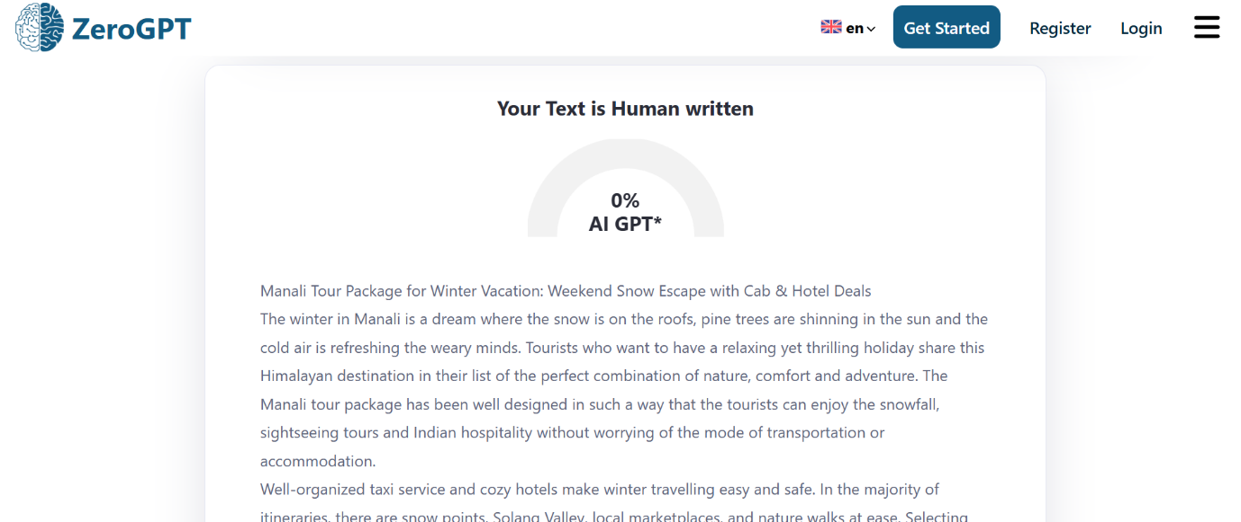

Manali Tour Package for Winter Vacation: Weekend Snow Escape with Cab & Hotel Deals
The winter in Manali is a dream where the snow is on the roofs, pine trees are shining in the sun and the cold air is refreshing the weary minds. Tourists who want to have a relaxing yet thrilling holiday share this Himalayan destination in their list of the perfect combination of nature, comfort and adventure. The Manali tour package has been well designed in such a way that the tourists can enjoy the snowfall, sightseeing tours and Indian hospitality without worrying about the mode of transportation or accommodation.
Well-organized taxi service and cozy hotels make winter travelling easy and safe. In the majority of itineraries, there are snow points, Solang Valley, local marketplaces, and nature walks at ease. Selecting the appropriate plan is useful to allow travelers to focus more on the scenery instead of logistics. Even a weekend getaway will feel fulfilling and perfect with a carefully planned holiday.
Winter Beauty and Peaceful Landscapes
Manali during winter is a serene place with clear morning, sunsets, and mountainous landscapes. Valleys are covered by snow, and there are great opportunities to take pictures and rest. Silent forests and fresh air assist the travelers to forget the busy life of the city. Each stroll in the town is invigorating and unforgettable.
Travelling with Friends and Groups
Going out with friends or work mates makes the winter holidays enjoyable. A Manali group tour package is tailored to individuals who enjoy staying together, predetermined plans, and sightseeing. Travelling as a group saves on total cost and simplifies planning. The sightseeing, bonfires, snow games and dinners form close ties and unforgettable experiences.
Wise Budget Traveler Planning
A large number of travelers seek cheaper winter deals that will not compromise comfort. A Kullu Manali budget trip package is concerned with clean hotels, safe transportation, and the obligatory sightseeing. These packages are appropriate to students, the first-time visitors and families that need to spend less and still enjoy important attractions. With budget planning, everyone can now afford winter traveling.
Relaxing Family Holidays
Family outings require security, adaptability and free time. Manali tour package for family and friends has facilities such as family friendly hotels, rooms with heating facilities and relaxed sightseeing. Old people take relaxing walks, children play in the snow, friends visit cafes and evening markets. These packages offer comfort and entertainment to everyone.
Why Choose Our Manali Tour Package for Family & Group
The Manali tour package will suit travellers who want Himalayas sceneries, stress-free tours and enjoyable moments in scenic locations. This Manali tour package for family & group is crafted to attract friends and groups and combines sightseeing, relaxation, and adventure. Visit Solang Valley, Kullu, Hadimba Temple, colorful markets, apple orchards, sightseeing of snow peaks, pine forests everywhere in an unending. Each day brings serene valleys, river walks and cultural sites providing comfort, excitement, safety, and memorable mountain scenes for all. Families enjoy safe tours, cozy accommodation, escorted sightseeing, child-friendly pacing, and everyone enjoys hospitality throughout the entire trip today. Transport lodging including meals and inclusions maximize value and guarantee smooth transfer of attractions on your holiday. It is pine-forest tracks, or high bazaars, there is a sense of balance, discovery, comfort, and pure Himalayan hospitality.
Sightseeing, Nature & Adventure Highlights
Adventure tourists love paragliding, skiing, river rafting, snow action, and some relax and have a beautiful view of the mountain. Teams connect due to common experiences, cultural experience, local food, photography, making memories that last after going back home together. Professional driver polite customer friendly itineraries and good support guarantee sightseeing timeliness, comfort and uniform quality during the departure. Whether organizing reunions trips, school trips, corporate outings or celebrations this Manali tour package adjusts easily to various travel tastes. You find beautiful villages, valley sides, attractions, hot springs, tunnels and panoramas that present the time-honored appeal of Manali beautifully. Flexible timings, considerate service and clear additions ensure that everyone arrives and leaves with ease, pleasant meals and happy endings. Select this Manali tour package for family & group when you prefer nature, comfort, adventure, and exceptional Himalayan memories. Book your Manali tour package now and enjoy with friends, travel comfortably, and make memories you will take forever.
Learning-Based Tours and Fast Travel
Manali tour package with flight saves on the long road travel and enables quicker arrival to the traveler who might have limited time. Easy transfers and chosen hotels allow you to make the most of sightseeing.
The Manali Package for school college is advantageous to student organizations since it is geared towards discipline, safety, and value of education. These trips are enjoyable and meaningful guided tours, fixed schedules and group activities.
FAQ’s
Q1. When should a winter tour to Manali be booked?
Making reservations at least three weeks beforehand is a sure way to get a better hotel room and a stable winter trip.
Q2. Are the roads safe during winter to tourists in Manali?
Yes, the majority of routes are regularly maintained and snow conditions are taken care of by experienced drivers to travel safely.
Q3. Are snow activities and permits included in winter packages?
Most packages feature basic snow point visits with adventure activities and special permits being organized separately should they be necessary.
Q4. What should be the ideal number of days spent in Manali during winter?
Four or five days is the best time to spend and have the pleasure of snowfall, sightseeing and unwind without hurrying on the itinerary.
Q5. Will Manali be a good place to spend winter as a senior citizen?
Yes, a heated hotel, slow itineraries, and access to the medical field make Manali in winter comfortable to seniors.

